Q1

Q2

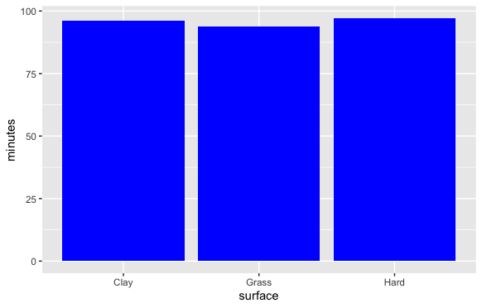

Q3

